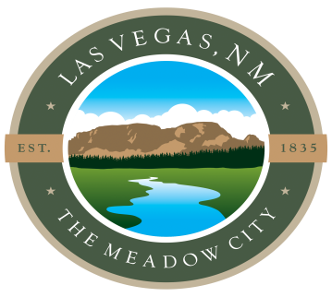

CITY OF LAS VEGAS WATER TREATMENT FAQ’s

Q: What chemicals are used to pre-treat and treat Gallinas River water?
A: Aluminum sulphate, polymer and sodium hypochlorite.

Q: Is our tap water safe to drink?
A: Yes. Water Treatment Plant staff are required to meet federal Safe Drinking Water Act standards. Water is treated by state certified water operators. Water quality is monitored by the New Mexico Environment Department Drinking Water Bureau through monthly reports, water sampling results, sanitary surveys, and random inspections. Annual consumer confidence reports are provided to the community.

Q: How often do Water Treatment Plant staff test for water quality?
A: City staff test water CONSTANTLY for turbidity & chlorine residual; DAILY for alkalinity, PH and dosing levels; MONTHLY for bacteria; QUARTERLY for TTHMS and HAA5s; and as required for inorganic and radioactive contaminants. Staff report the results to the New Mexico Environment Department Drinking Water Bureau to ensure compliance with the federal Safe Drinking Water Act Standards.

Q: What are the requirements to treat drinking water and to work at the city’s water treatment plant?
A: To make process changes and treat our citys water to drinking water standards, the water operators must hold the water system operator level consistent with the type of treatment. The City of Las Vegas system requires level 4 operators to manage and run our treatment plant. Uncertified operators can perform tasks that do not require process changes or must have the appropriate level of operator in direct supervisor if they are to assist with treatment processes.

Q: What is the consumer confidence report?
A: Consumer Confidence Reports (CCRs), also known as drinking water quality reports, provide you with important information about the quality of your drinking water. The U.S. Environmental Protection Agency (EPA) requires every community water supplier to provide a CCR to their customers.

Q: How often do city staff communicate with New Mexico Environment Department staff?
A: At minimum monthly with there being increased communication during an emergency such as the 4 times per day we were communicating during the fire. City staff and NMED staff will communicate whenever there is a question regarding the safe drinking water act, sampling, operations, inspections, whenever the city is looking for additional input, and whenever there is a project involving the city’s drinking water system.

